Lab 01: Implementation or RPC (Remote Procedure Call)

Name: Aviskar Poudel
Roll No.: ACE079BCT013
Submitted to: Department of Electronics and Computer Engineering
Advanced College of Engineering and Management

Objective
- To understand the fundamental concept of Remote Procedure Call (RPC) in distributed systems.
- To implement Remote Procedure Call (RPC) using pyro4.

Theory
RPC stands for Remote Procedure Call and its implementation refers to the internal mechanism that enables a client to invoke a procedure on a remote server if it were a local function call. It provides the technical framework for remote communication. It manages interaction between client server components and it also handles data conversion and message transmission.

The block diagram of the RPC implementation can be given as:
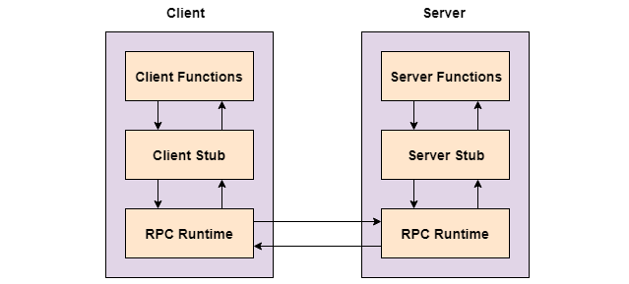
Fig: Remote Procedure Call Block
We can think of it like ordering food at a restaurant:
- You (the client) tell the waiter (the RPC mechanism) what you want.
- The waiter communicates with the kitchen (the server) to prepare the food.
- The kitchen (server) completes the order and gives it to the waiter.
- The waiter delivers the food back to you.
In this analogy:
- You = The client node
- The waiter = RPC framework
- The kitchen = The server node

There are 4 major components when we discuss about RPC:
- Communication Protocol
It is the set of rules that helps the client and server communicate with each other over the network. It decides how messages are sent, received, and understood properly.
- Marshaling and Unmarshaling
Marshaling means converting data into a format that can be transmitted over the network. Unmarshaling means converting that received data back into its original usable form.
- Client and Server
The client is the system that requests a service or function. The server is the system that processes the request and sends back the result.
- Middleware and Heterogeneity
Middleware is the software layer between the client and server that manages communication and coordination. It helps both sides interact smoothly without worrying about network details. Heterogeneity means different systems, devices, or programming languages working together in RPC. RPC handles these differences so communication can happen correctly.

Other Terms:
Interface Definition Language: IDL is a language used to define the functions and services that a remote server provides. It acts like a contract between the client and server so both know what functions, inputs, and outputs are available. Client gets knowledge about server features and functions by the help of User Interface.
Daemon Registration: Daemon registration is the process where a background service (daemon) announces its availability in a distributed system. When it starts, it registers itself with a registry or middleware by giving details like service name, IP address, port number, and available functions. This helps clients find the service without knowing its exact location. The registry stores all active services and acts like a directory. When a client requests a service, it checks this registry to locate the correct daemon. If the daemon stops, it is removed or unregistered so the registry stays updated.
Pyro4: It is a library that enables you to build applications in which objects can talk to each other over the network, with minimal programming effort. You can just use normal Python method calls to call objects on other machines. Pyro is a pure Python library and runs on many different platforms and Python versions.
Source Code
client.py
- import Pyro4

- # Prompt the user to enter the URI of the server
- uri = input("Enter the URI of the server: ")

- # Connect to the server
- calc = Pyro4.Proxy(uri)

- # Function to perform addition
- def perform_addition():
- x = float(input("Enter the first number: "))
- y = float(input("Enter the second number: "))
- result = calc.add(x, y)
- print("Result of addition:", result)

- # Function to perform subtraction
- def perform_subtraction():
- x = float(input("Enter the first number: "))
- y = float(input("Enter the second number: "))
- result = calc.subtract(x, y)
- print("Result of subtraction:", result)

- # Interactive menu
- while True:
- print("\nChoose an operation:")
- print("1. Addition")
- print("2. Subtraction")
- print("3. Exit")

- choice = input("Enter your choice (1/2/3): ")

- if choice == "1":
- perform_addition()
- elif choice == "2":
- perform_subtraction()
- elif choice == "3":
- print("Exiting client.")
- break
- else:
- print("Invalid choice. Please enter 1, 2, or 3.")

server.py
- import Pyro4

- @Pyro4.expose
- class Calculator(object):
- def add(self, x, y):
- return x + y

- def subtract(self, x, y):
- return x - y

- # Create a Pyro4 daemon
- daemon = Pyro4.Daemon()
- uri = daemon.register(Calculator)

- # Print the URI
- print("Server URI:", uri)

- # Start the server
- print("Calculator server started. Press Ctrl+C to exit.")

- try:
- daemon.requestLoop()
- except KeyboardInterrupt:
- print("\nExiting Calculator server.")
- daemon.shutdown()

Output:
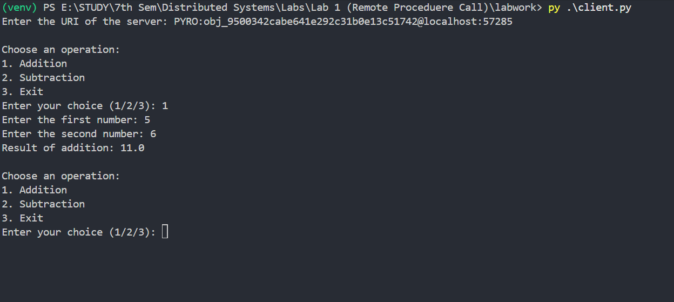

Discussion and Conclusion
In this lab of Distributed Systems, we implemented RPC using pyro4. We understood how a client call functions in remote server and how server responds to it as if they are local functions. In pyro4, we created a basic calculator using this concept of RPC.
We also learnt about daemon registration process. The server creates a pyro daemon using pyro4.daemon() and then registered the calculator object using daemon.register(Calculator). It helps to assign an unique URI to the remote object. Then the client can use the URI for invocation without knowing the actual IP and port of the server.

In conclusion, we learned the fundamental concept of Remote Procedure Call and how it can help us to communicate between client and server and client accessing server through proxy using a unique generated URI using pyro4. We also understood the importance of daemon registration where server can register the remote objects with a Pyro daemon so that they can be accessed by clients over the network.

